**Exercise 8. Visualizing, Thresholding, and Projecting Niche Models**

|  |  |
| --- | --- |
| Skills Acquired | Data Required |
| * Evaluate the fit of a model using variable response curves * Thresholding a continuous model output into a binary model output * Project models into a new time * Identify areas of model extrapolation in model projections | * Future predictions of climate variables |

**Step 1. Visualizing Model Results**

Now that we’ve seen the numbers, let’s get an idea of what our niche models look like in terms of inferred response curves and geography.

NOTE: Remember to click on the “Component Guidance” tab if you need a refresher overview on niche/distributional models and the “Module Guidance” tab if you need additional information about the occurrence data partitioning methods.

* *Click on “7 Visualize” in the browser window in which Wallace is running.*

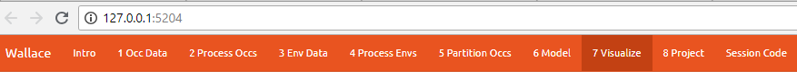

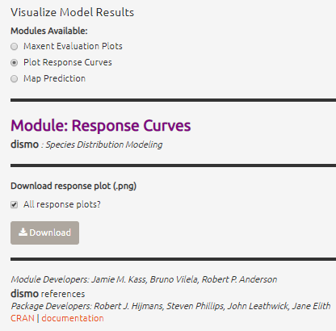

* *Plot response curves*

1. Under “Visualize Model Results” select the “Plot Response Curves” radio button.
2. In the “Results” window to the right, you’ll see a single plot for the first environmental variable. NOTE: The Wallace interface only permits you to view one response curve at a time. To view response curves for other environmental variables used in modeling, look above the far right side of the plot. There you will see 3 drop down menus. Click on the “Current Env Variable” dropdown menu and select the variable you want to view… If you wish to view the response curves for all variables simultaneously, we will need to download the plots.
3. **Save the response plots.** Under “Download response plot (.png)”, check the box next to “All response plots?” then Download. Save the .png file to your working project folder as “*Gymnosarda-response-plots.png*”.
4. Now open “*Gymnosarda-response-plots.png*” to examine all response plots side-by-side. Example provided below.

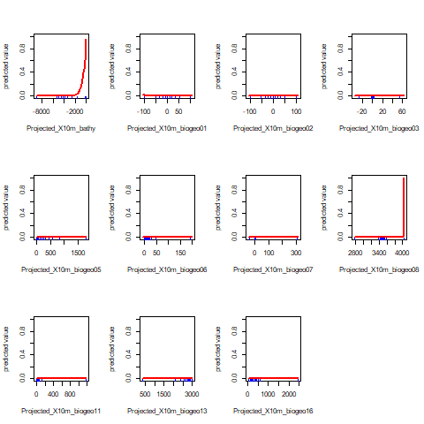

Example response curve plot output from Wallace.

1. What information can we infer from these plots? Do you think all environmental variables (covariates) included are necessary (e.g., are there variables that do not seem to contribute to the model)? If ‘no’, what variables would you remove? Why? How do incompletely characterized variables impact our ability to reliably project a niche model?
2. Refining covariate selection: If you determined that variables should be removed in step ‘e’, go back and rerun your model excluding the variables you opted to drop up through the last step (this will require going back to Exercise 5 Part B: Loading environmental data in Wallace). Remember to give any output files names that are unique from the files saved during your first round of modeling.

Now, let’s compare the original model calibrated with the full set of covariates to your new, refined model.

MODEL SELECTION: How do the AICc values compare for the best models from the two calibration methods? What about the omission rates?

RESPONSE CURVES: What can you infer from the response curves for your refined model? Are you satisfied with your selected environmental variables? Why/why not?

g) Repeat the process in step ‘f’ until you feel confident you’ve settled upon the ideal

number and range of covariates. What is the final set of covariates to be used?

* *Visualize model results in geographic space*

1. Under “Visualize Model Results” select the “Map Prediction” radio button.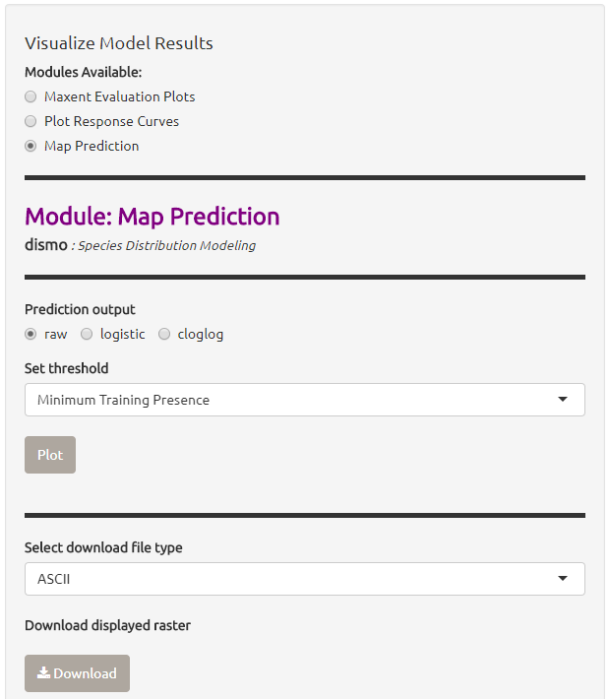
2. If you look to the right above you map, you’ll see 3 drop down menus. Click on the “Current Model” dropdown menu and select the model that performed best according to your model evaluation statistics in Exercise 6.
3. Under “Modules Available” select the “Map Prediction” radio button.
4. Under “Prediction Output” select the “raw” radio button.
5. From the “Set threshold” dropdown menu, choose the threshold (minimum training presence or 10 percentile training) that yielded the best omission rate accord to the model evaluation in Exercise 6.
6. Click on “Plot”. Your thresholded binary model results for the calibration/training region should appear in the display window with the extent of the training region denoted in red (an example is below).

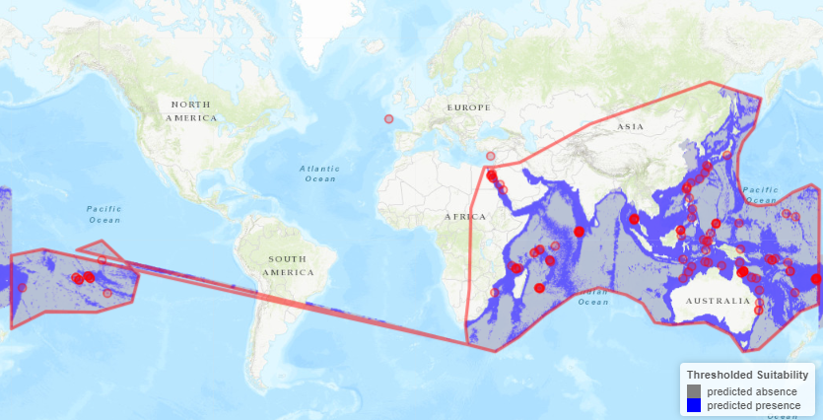

1. Now, take a few minutes to explore the three alternate model projection options. That is, if your best evaluated model was LQHP_2 with a MTP threshold, then take a minute to visualize LQHP_2 with a 10 Percentile Training Threshold, LQHP_1 with a MTP, and LQHP_2 with a 10 Percentile Training Threshold.

What similarities do you see across the four visualization? What are the major differences?

1. **Save your model prediction.** First, be sure to return all settings to reflect your selected model and threshold. Then, select “ASCII” from the “Select download file type” dropdown menu, and press “Download”. Save the file to your working project folder.

**Step 2. Niche model projection.**

As discussed in lecture, niche/distributional models can be projected to different geographic and/or bioclimatic environments. Here we will project our calibrated niche models to a new geographic region.

REMEMBER: if you need a refresher on the background of model projection, click on the “Component Guidance” tab; if you need additional information about the model projection process, click on the “Module Guidance” tab.

* *Click on “8 Project” in the browser window in which Wallace is running.*



* *Choosing your model parameters.*

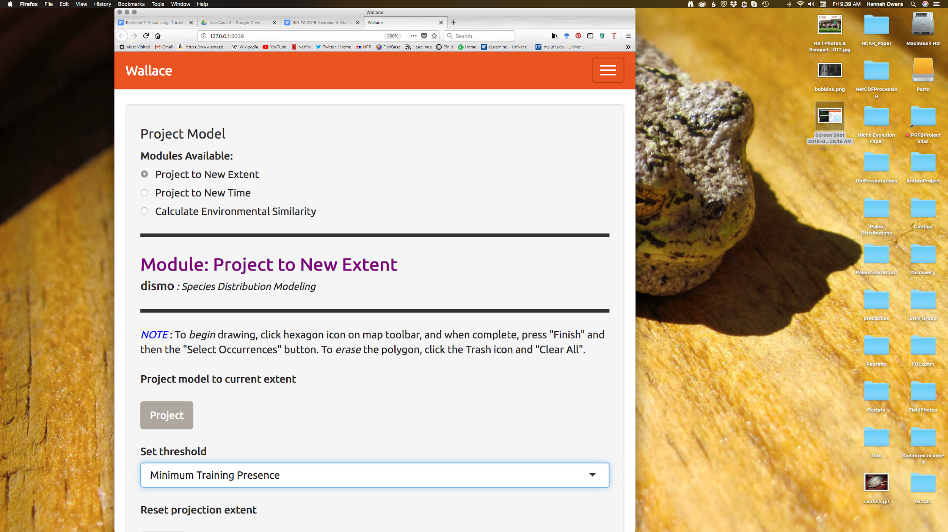

1. Under “Modules Available”, select the “Project to New Extent” radio button.
2. Click on “Draw a Polygon” on the left-hand of the map, then draw a polygon of the desired new extent (it’s shaped like a pentagon; red circle to the right). NOTES: Only project to the region you’re interested in. Global projections take a long time, and a lot of computing power. Also, a limitation of Wallace is that the new extent (the projection region) must include the full extent of the calibration region.

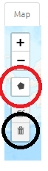

1. From the “Set threshold” dropdown menu, select the same threshold you chose in Part A (based on the “Model Evaluation” component of Exercise 6).
2. Press “Project” under “Project model to current extent”. Be patient; it takes time to mask environmental grids to the new extent and project the model to this new area.
3. Once the model projection is complete, delete the projection polygon you drew. To do this, click on the garbage can icon on the left side of the map (circled in black) and press “Clear all”. This should leave the polygon outline but remove the gray fill so you are able to view the model projection results.

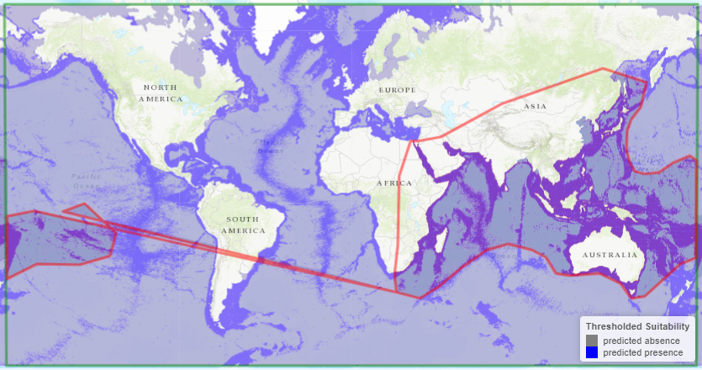

1. **Save your model projection.** Under the “Select download file type” dropdown menu, select “ASCII”. Press “Download”. Save the file to your working project folder. NOTE: The file name automatically generated by Wallace is the exact same as the file name produced for the model training and projection files (the format includes the feature class selection of the model, the model number, and the selected threshold). As such, be sure to add “_proj” to the end of the file name. For example, the projection file name for the example provided here would be “LQHP_2_thresh_mtp_proj.asc”.

* *Model Interpretation.*

Look closely at your projected model. Based on what you know about our study species, *Gymnosarda arcus*, do your model results make sense? Are there any areas of predicted absence or presence that are questionable? What areas? Why do you question the model prediction in these areas?

**Step 3: Calculating Environmental Similarity.**

MESS analyses allow us to characterize the degree to which the model projection region differs from the the bioclimatic conditions of the model calibration region.

1. Under “Project Model: Modules Available” select the “Calculate Environmental Similarity” radio button.
2. Press the “Calculate MESS” button under “Calculate MESS for current extent”. Be patient; this process can take a fair bit of time depending on the geographic extent and spatial resolution of your data.
3. Look at the resulting map. What stands out most? REMEMBER: High positive values indicate increasing similarity with the conditions used to train the model, and low negative values indicate increasing difference relative to the model calibration bioclimatic conditions. See example below.

Example MESS output from Wallace.

1. **Save MESS evaluation.** Under the “Select download file type” dropdown menu, select “GeoTIFF”. Then press “Download”. Save the file to your working project folder. NOTE: The file name automatically generated by Wallace is the exact same as the file name produced for the model training and projection files (the format includes the feature class selection of the model, the model number, and the selected threshold). As such, be sure to add “_MESS” to the end of the file name. For example, the file name for the example provided here would be “LQHP_2_thresh_mtp_MESS.asc”.

**Step 4. Saving Your Session Code.**

It’s best practice to always maintain detailed records of the specific steps taken during research. Conveniently, Wallace provides us with the option to download a record of actions taking during the modeling session.

* *Click on “Session Code” in the browser window in which Wallace is running***.**



* *Download and Save Session Code.*

1. Under “Select download file type” dropdown menu, choose “WORD.
2. Click on “Download Session Code”. Save the file to your working project folder. The default file name should work just fine.